THE MIXED NUTS
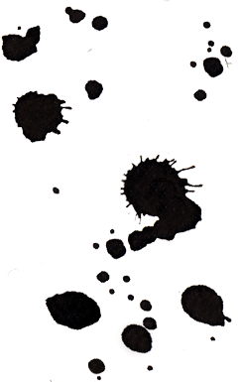
Set EE Last revised on 2016.06.14

EE01-I'm Sittin' On Top Of The World(KVF).2015.09.20.pdf
EE01-I'm Sittin' On Top Of The World(KVM).2015.09.20.pdf
EE02-In The Good Old Summertime(KVF).2015.08.09.pdf
EE02-In The Good Old Summertime(KVM).2015.08.09.pdf
EE03-There Will Never Be Another You(KVF).2015.09.20.pdf
EE03-There Will Never Be Another You(KVM).2015.09.20.pdf
EE04-It's Been A Long, Long Time(KVF).2015.08.09.pdf
EE04-It's Been A Long, Long Time(KVM).2015.08.09.pdf
EE05-Side By Side(KVF).2016.06.14.pdf
EE05-Side By Side(KVM).2016.06.14.pdf
EE06-For Once In My Life(KVF).2015.09.20.pdf
EE06-For Once In My Life(KVM).2015.09.20.pdf
EE07-Shine On, Harvest Moon(KVF).2015.09.20.pdf
EE07-Shine On, Harvest Moon(KVM).2015.09.20.pdf
EE08-Tuxedo Junction(KV).2016.06.14.pdf
EE09-If I Didn't Care(KVF).2015.08.09.pdf
EE09-If I Didn't Care(KVM).2015.08.09.pdf
EE10-The Gypsy(KVF).2015.01.15.pdf
EE10-The Gypsy(KVM).2015.01.15.pdf
EE11-To Each His Own(KVF).2015.08.09.pdf
EE11-To Each His Own(KVM).2015.08.09.pdf
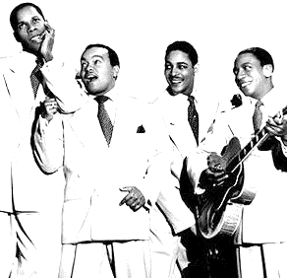
EE12-Rain Rain Polka(K).2015.08.09.pdf
EE13-Goodnight Sweetheart(KVF).2015.01.15.pdf
EE13-Goodnight Sweetheart(KVM).2015.01.15.pdf
EE14-Oh Johnny, Oh(KVF).2014.01.01.pdf
EE14-Oh Johnny, Oh(KVM).2014.01.01.pdf
EE15-I Feel Pretty(KV).2015.08.09.pdf
EE16-My Foolish Heart(KVF).2016.05.30.pdf
EE16-My Foolish Heart(KVM).2016.05.30.pdf
EE17-American Patrol(K).2016.06.14.pdf

